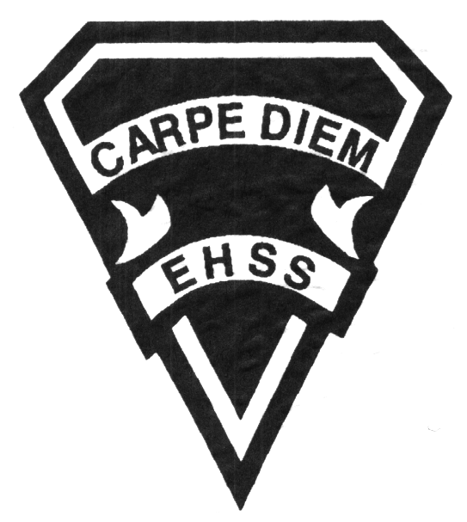

## Earl Haig

SecondarySchool

**2020/2021**

### Canadian and World Issues

**Social Sciences Department**

# **CGW4U**

**Evaluation Profile & Outline**

**Course Description/Rationale/Overview:** This course draws upon geographic concepts, skills, methods and technologies to analyze significant issues facing Canadians as citizens of our interconnected world. Students will examine the challenges of creating a sustainable and equitable future through the study of a range of topics including economic interdependence, geopolitical conflict, and regional disparities in the ability to meet basic human needs and protection of the planet’s life support systems.

**Class Requirements:**

Students should have materials specified by the subject teacher at the beginning of the year.

The is no assigned textbook for this course. Supplemental resources will be provided by the instructor.

**Assessment and Evaluation Strategies**

Students will also be expected to complete assessment activities of a formative nature in order to learn and to practice the specific expectations that will compose the summative evaluations. Examples of formative assessment may include homework checks, quizzes, peer assessment, presentations, reflection writing, role-play scenarios and observation.

Each unit or strand of the course will be evaluated using summative evaluations. Examples of summative evaluations are tests, case studies, interviews, reports, presentations, seminars, debates, research and other writing assignments.

**Late and/or Missed Evaluation**

##### Late Assignments

For each assignment, the teacher will inform students of the due date and the ultimate deadline. The ultimate deadline is the last opportunity for students to submit an assignment for evaluation. If an assignment is submitted after the ultimate deadline, it will not be evaluated and a mark of zero will be assigned. In certain circumstances, the student may be granted an extension of the ultimate deadline at the teacher’s discretion, only if an arrangement has been made with the teacher beforehand.

**Subject-Specific/Department Information**

Teachers in the Social Sciences Department can be reached at (416) 395-3210, ext. 20075 or 20085. Parents wishing to meet with a teacher are requested to make an appointment with the teacher prior to coming to the school.

**Learning Skills**

**Responsibility** – meets deadlines; takes responsibility for own behaviour

**Organization** – establishes priorities and manages time; uses information, technology, and resources top complete tasks time management

**Independent Work** – follows instruction with minimal supervision; uses class time appropriately to complete tasks

**Collaboration** – accepts an equitable share of work in a group; builds healthy peer relationships; works with others to achieve group goals

**Initiative** – looks for opportunities for learning; demonstrates curiosity; approaches new tasks with a positive attitude

**Self-regulation** – sets own goals and monitors own progress; seeks assistance with needed; makes an effort with responding to challenges

**Achievement Categories and Weighting**

* **Knowledge / Understanding – 15%**

Knowledge of facts and terms; understanding of concepts, principles, guidelines, and strategies; understanding of relationships among concepts.

* **Application – 30%**

Synthesizing knowledge and understanding into new and familiar contexts as well as making connections between various contexts.

* **Thinking Inquiry – 25%**

Formulating questions; planning, selecting strategies and resources; analyzing and interpreting information, and forming conclusions.

* **Communication – 30%**

Communication of information and ideas, communication for different audiences, use of various forms of communication.

###### Final Mark

The final mark for this course will be determined based upon an accumulation of marks form course work and a position paper.

**Course Work 85%**

This is a culmination of evaluations that have been completed throughout the year. It may include tests, presentations, research, or topic specific assignments.

**Position Paper 15%**

This will be based on a previously chosen topic and a collection of resources which will have been collected in units 1-4. The research components, as well as the paper itself, will constitute the total mark.

*From: Ontario Ministry of Education. *Growing Success: Assessment, Evaluation, and Reporting in Ontario Schools*. Toronto: Ministry of Education, 2010, 11.



## Earl Haig

SecondarySchool

**2020/2021**

##### Canadian and World

##### Issues

**Social Sciences Department**

# **CGW4U**

**Evaluation Profile & Outline**

**Course Outline:**

**Unit 1: Understanding World Issues**

This unit is an introduction to World Issues and Geography. The focus will be on geographic thinking concepts and geographic perspectives and the investigation of issues that arise from the global commons on a finite planet.

**Unit 2: Population Growth and Globalization**

In this unit, specific world issues will be examined that affect many countries with a focus on the Asian continent. Issues concerning rapid population growth and decline will be examined, as well as the economic, environmental, political, and social impacts of globalization.

**Unit 3: Disparities and Inequities**

The unit focus will be on Africa and the many issues facing the continent. The multitude of inequalities between and within countries will be investigated that may include food security, natural resources, conflict, and human rights.

**Unit 4: Environmental Sustainability**

In this unit, the focus will be on environmental sustainability. This will include a variety of topics, such as the examination of personal choices, water issues, immigration, and environmental dilemmas.